[1.5, 0.5, 1.0]

1 run......

training 1 epoch...

26.61012053489685 seconds used......

1 training finished! average train loss: 0.8685072081930497

evaluating...

Confusion matrix, without normalization

[[ 423 0 350]

[ 190 1 239]

[ 332 2 1995]]

Normalized confusion matrix

[[0.54721863 0. 0.45278137]

[0.44186047 0.00232558 0.55581395]

[0.14255045 0.00085874 0.85659081]]

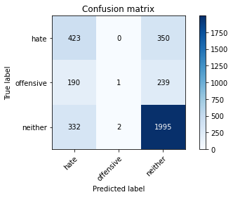

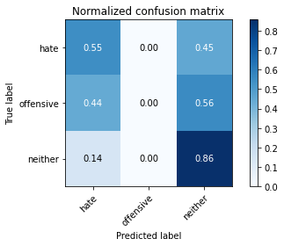

precision recall f1-score support

hate 0.45 0.55 0.49 773

offensive 0.33 0.00 0.00 430

neither 0.77 0.86 0.81 2329

accuracy 0.68 3532

macro avg 0.52 0.47 0.44 3532

weighted avg 0.65 0.68 0.64 3532

average eval_loss: 0.7037796041386276, accuracy: 0.684881087202718

training 2 epoch...

26.633482456207275 seconds used......

2 training finished! average train loss: 0.6198897237944252

evaluating...

Confusion matrix, without normalization

[[ 473 31 269]

[ 152 90 188]

[ 305 73 1951]]

Normalized confusion matrix

[[0.61190168 0.04010349 0.34799483]

[0.35348837 0.20930233 0.4372093 ]

[0.13095749 0.03134392 0.83769858]]

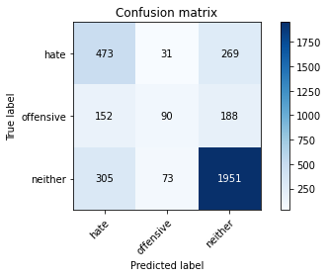

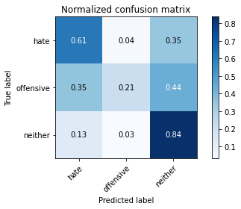

precision recall f1-score support

hate 0.51 0.61 0.56 773

offensive 0.46 0.21 0.29 430

neither 0.81 0.84 0.82 2329

accuracy 0.71 3532

macro avg 0.59 0.55 0.56 3532

weighted avg 0.70 0.71 0.70 3532

average eval_loss: 0.6721941834620837, accuracy: 0.7117780294450736

training 3 epoch...

26.47281575202942 seconds used......

3 training finished! average train loss: 0.4212546095471172

evaluating...

Confusion matrix, without normalization

[[ 585 31 157]

[ 212 116 102]

[ 568 102 1659]]

Normalized confusion matrix

[[0.75679172 0.04010349 0.20310479]

[0.49302326 0.26976744 0.2372093 ]

[0.24388149 0.04379562 0.71232289]]

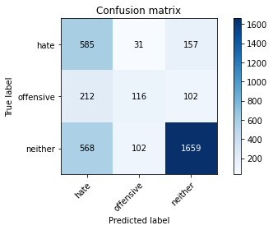

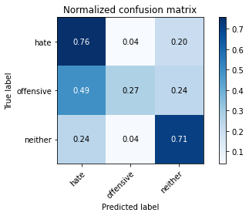

precision recall f1-score support

hate 0.43 0.76 0.55 773

offensive 0.47 0.27 0.34 430

neither 0.86 0.71 0.78 2329

accuracy 0.67 3532

macro avg 0.59 0.58 0.56 3532

weighted avg 0.72 0.67 0.68 3532

average eval_loss: 0.7955254030092961, accuracy: 0.6681766704416761

training 4 epoch...

26.579980611801147 seconds used......

4 training finished! average train loss: 0.2345631359528531

evaluating...

Confusion matrix, without normalization

[[ 443 74 256]

[ 135 162 133]

[ 289 156 1884]]

Normalized confusion matrix

[[0.57309185 0.09573092 0.33117723]

[0.31395349 0.37674419 0.30930233]

[0.12408759 0.06698154 0.80893087]]

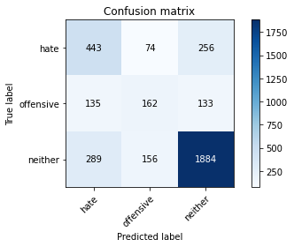

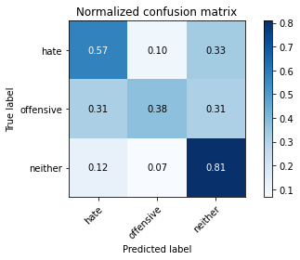

precision recall f1-score support

hate 0.51 0.57 0.54 773

offensive 0.41 0.38 0.39 430

neither 0.83 0.81 0.82 2329

accuracy 0.70 3532

macro avg 0.58 0.59 0.58 3532

weighted avg 0.71 0.70 0.71 3532

average eval_loss: 0.8991858709161564, accuracy: 0.7046998867497168

training 5 epoch...

26.550663709640503 seconds used......

5 training finished! average train loss: 0.1104790734620217

evaluating...

Confusion matrix, without normalization

[[ 324 94 355]

[ 86 169 175]

[ 154 133 2042]]

Normalized confusion matrix

[[0.41914618 0.12160414 0.45924968]

[0.2 0.39302326 0.40697674]

[0.0661228 0.05710605 0.87677115]]

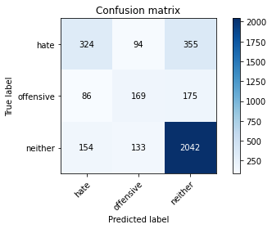

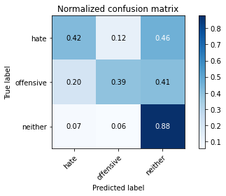

precision recall f1-score support

hate 0.57 0.42 0.48 773

offensive 0.43 0.39 0.41 430

neither 0.79 0.88 0.83 2329

accuracy 0.72 3532

macro avg 0.60 0.56 0.58 3532

weighted avg 0.70 0.72 0.71 3532

average eval_loss: 1.1801912355641861, accuracy: 0.7177236693091733

training 6 epoch...

26.551148176193237 seconds used......

6 training finished! average train loss: 0.05580369253156652

evaluating...

Confusion matrix, without normalization

[[ 404 102 267]

[ 99 189 142]

[ 250 190 1889]]

Normalized confusion matrix

[[0.52263907 0.13195343 0.3454075 ]

[0.23023256 0.43953488 0.33023256]

[0.10734221 0.08158008 0.81107772]]

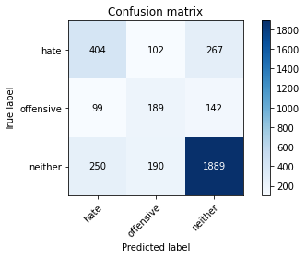

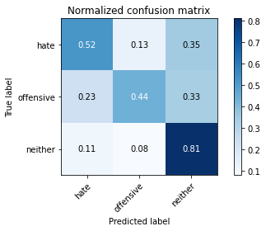

precision recall f1-score support

hate 0.54 0.52 0.53 773

offensive 0.39 0.44 0.41 430

neither 0.82 0.81 0.82 2329

accuracy 0.70 3532

macro avg 0.58 0.59 0.59 3532

weighted avg 0.71 0.70 0.70 3532

average eval_loss: 1.2839909810888566, accuracy: 0.702718006795017

training 7 epoch...

26.577879428863525 seconds used......

7 training finished! average train loss: 0.027218067075249135

evaluating...

Confusion matrix, without normalization

[[ 308 113 352]

[ 68 187 175]

[ 143 143 2043]]

Normalized confusion matrix

[[0.39844761 0.1461837 0.45536869]

[0.15813953 0.43488372 0.40697674]

[0.06139974 0.06139974 0.87720052]]

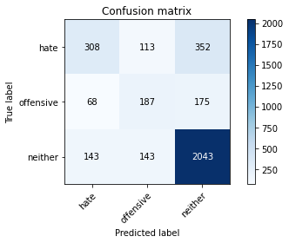

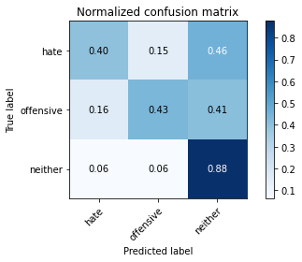

precision recall f1-score support

hate 0.59 0.40 0.48 773

offensive 0.42 0.43 0.43 430

neither 0.79 0.88 0.83 2329

accuracy 0.72 3532

macro avg 0.60 0.57 0.58 3532

weighted avg 0.71 0.72 0.71 3532

average eval_loss: 1.4388358787038906, accuracy: 0.7185730464326161

training 8 epoch...

26.485674619674683 seconds used......

8 training finished! average train loss: 0.02370363975077292

evaluating...

Confusion matrix, without normalization

[[ 387 113 273]

[ 100 188 142]

[ 223 168 1938]]

Normalized confusion matrix

[[0.50064683 0.1461837 0.35316947]

[0.23255814 0.4372093 0.33023256]

[0.09574925 0.07213396 0.83211679]]

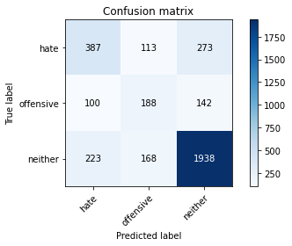

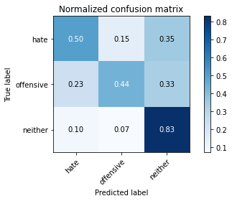

precision recall f1-score support

hate 0.55 0.50 0.52 773

offensive 0.40 0.44 0.42 430

neither 0.82 0.83 0.83 2329

accuracy 0.71 3532

macro avg 0.59 0.59 0.59 3532

weighted avg 0.71 0.71 0.71 3532

average eval_loss: 1.4272902786815906, accuracy: 0.7114949037372593

training 9 epoch...

26.563857555389404 seconds used......

9 training finished! average train loss: 0.013241641532016835

evaluating...

Confusion matrix, without normalization

[[ 357 153 263]

[ 79 229 122]

[ 206 258 1865]]

Normalized confusion matrix

[[0.461837 0.19793014 0.34023286]

[0.18372093 0.53255814 0.28372093]

[0.08844998 0.11077716 0.80077286]]

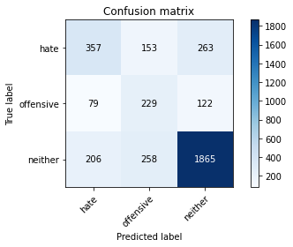

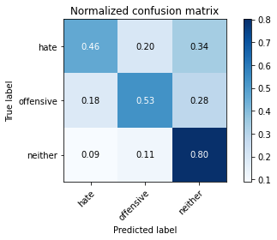

precision recall f1-score support

hate 0.56 0.46 0.50 773

offensive 0.36 0.53 0.43 430

neither 0.83 0.80 0.81 2329

accuracy 0.69 3532

macro avg 0.58 0.60 0.58 3532

weighted avg 0.71 0.69 0.70 3532

average eval_loss: 1.6432195280568074, accuracy: 0.6939411098527747

training 10 epoch...

26.581098318099976 seconds used......

10 training finished! average train loss: 0.008889230723177795

evaluating...

Confusion matrix, without normalization

[[ 423 93 257]

[ 124 182 124]

[ 274 165 1890]]

Normalized confusion matrix

[[0.54721863 0.12031048 0.33247089]

[0.28837209 0.42325581 0.28837209]

[0.11764706 0.07084586 0.81150708]]

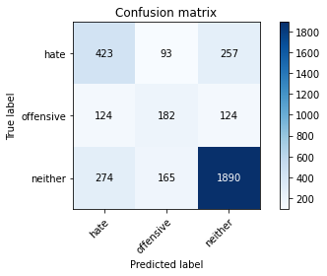

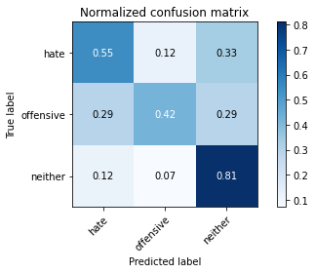

precision recall f1-score support

hate 0.52 0.55 0.53 773

offensive 0.41 0.42 0.42 430

neither 0.83 0.81 0.82 2329

accuracy 0.71 3532

macro avg 0.59 0.59 0.59 3532

weighted avg 0.71 0.71 0.71 3532

average eval_loss: 1.5469542708311042, accuracy: 0.7063986409966025

2 run......

training 1 epoch...

26.635603666305542 seconds used......

1 training finished! average train loss: 0.8317573478116709

evaluating...

Confusion matrix, without normalization

[[ 531 10 232]

[ 244 41 145]

[ 475 46 1808]]

Normalized confusion matrix

[[0.68693402 0.01293661 0.30012937]

[0.56744186 0.09534884 0.3372093 ]

[0.20395019 0.01975097 0.77629884]]

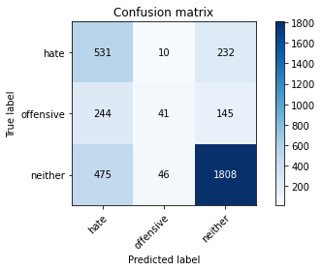

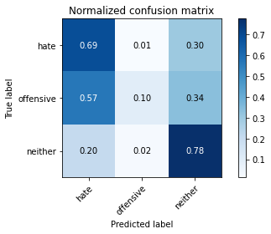

precision recall f1-score support

hate 0.42 0.69 0.52 773

offensive 0.42 0.10 0.16 430

neither 0.83 0.78 0.80 2329

accuracy 0.67 3532

macro avg 0.56 0.52 0.49 3532

weighted avg 0.69 0.67 0.66 3532

average eval_loss: 0.731751483544118, accuracy: 0.6738391845979615

training 2 epoch...

26.49624252319336 seconds used......

2 training finished! average train loss: 0.5971203525276745

evaluating...

Confusion matrix, without normalization

[[ 523 12 238]

[ 210 68 152]

[ 413 47 1869]]

Normalized confusion matrix

[[0.67658473 0.01552393 0.30789133]

[0.48837209 0.15813953 0.35348837]

[0.17732933 0.02018033 0.80249034]]

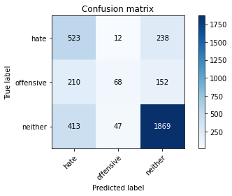

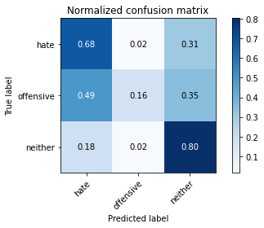

precision recall f1-score support

hate 0.46 0.68 0.55 773

offensive 0.54 0.16 0.24 430

neither 0.83 0.80 0.81 2329

accuracy 0.70 3532

macro avg 0.61 0.55 0.53 3532

weighted avg 0.71 0.70 0.69 3532

average eval_loss: 0.675254113593344, accuracy: 0.6964892412231031

training 3 epoch...

26.62442708015442 seconds used......

3 training finished! average train loss: 0.39109034124104414

evaluating...

Confusion matrix, without normalization

[[ 553 30 190]

[ 211 102 117]

[ 482 122 1725]]

Normalized confusion matrix

[[0.71539457 0.03880983 0.2457956 ]

[0.49069767 0.2372093 0.27209302]

[0.20695578 0.052383 0.74066123]]

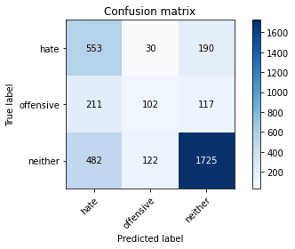

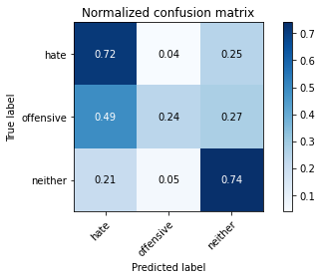

precision recall f1-score support

hate 0.44 0.72 0.55 773

offensive 0.40 0.24 0.30 430

neither 0.85 0.74 0.79 2329

accuracy 0.67 3532

macro avg 0.56 0.56 0.55 3532

weighted avg 0.71 0.67 0.68 3532

average eval_loss: 0.7704011759178787, accuracy: 0.6738391845979615

training 4 epoch...

26.576866626739502 seconds used......

4 training finished! average train loss: 0.2244144427754423

evaluating...

Confusion matrix, without normalization

[[ 501 64 208]

[ 168 143 119]

[ 369 171 1789]]

Normalized confusion matrix

[[0.64812419 0.08279431 0.2690815 ]

[0.39069767 0.33255814 0.27674419]

[0.1584371 0.07342207 0.76814083]]

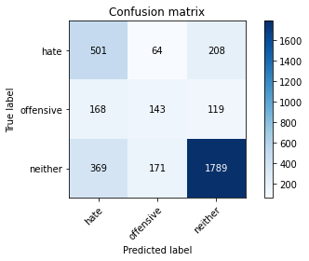

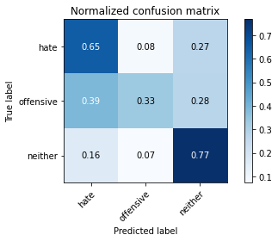

precision recall f1-score support

hate 0.48 0.65 0.55 773

offensive 0.38 0.33 0.35 430

neither 0.85 0.77 0.80 2329

accuracy 0.69 3532

macro avg 0.57 0.58 0.57 3532

weighted avg 0.71 0.69 0.69 3532

average eval_loss: 0.9495058828322901, accuracy: 0.6888448471121178

training 5 epoch...

26.65150260925293 seconds used......

5 training finished! average train loss: 0.09221792839440134

evaluating...

Confusion matrix, without normalization

[[ 412 145 216]

[ 87 230 113]

[ 255 285 1789]]

Normalized confusion matrix

[[0.53298836 0.18758085 0.27943079]

[0.20232558 0.53488372 0.2627907 ]

[0.10948905 0.12237012 0.76814083]]

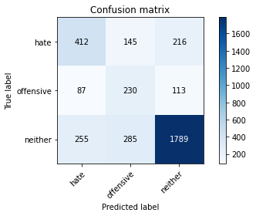

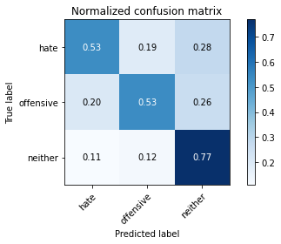

precision recall f1-score support

hate 0.55 0.53 0.54 773

offensive 0.35 0.53 0.42 430

neither 0.84 0.77 0.80 2329

accuracy 0.69 3532

macro avg 0.58 0.61 0.59 3532

weighted avg 0.72 0.69 0.70 3532

average eval_loss: 1.2113016446431477, accuracy: 0.6882785956964892

training 6 epoch...

26.589963674545288 seconds used......

6 training finished! average train loss: 0.03599910691777682

evaluating...

Confusion matrix, without normalization

[[ 379 130 264]

[ 84 220 126]

[ 205 243 1881]]

Normalized confusion matrix

[[0.49029754 0.16817594 0.34152652]

[0.19534884 0.51162791 0.29302326]

[0.08802061 0.10433663 0.80764277]]

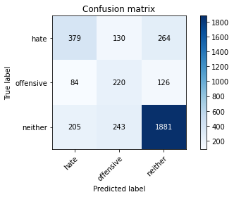

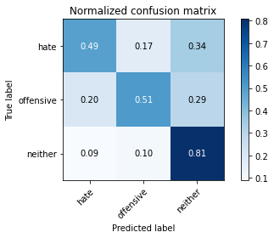

precision recall f1-score support

hate 0.57 0.49 0.53 773

offensive 0.37 0.51 0.43 430

neither 0.83 0.81 0.82 2329

accuracy 0.70 3532

macro avg 0.59 0.60 0.59 3532

weighted avg 0.72 0.70 0.71 3532

average eval_loss: 1.4510140742285778, accuracy: 0.7021517553793885

training 7 epoch...

26.50424838066101 seconds used......

7 training finished! average train loss: 0.027322899515959707

evaluating...

Confusion matrix, without normalization

[[ 415 100 258]

[ 110 190 130]

[ 258 196 1875]]

Normalized confusion matrix

[[0.53686934 0.12936611 0.33376455]

[0.25581395 0.44186047 0.30232558]

[0.11077716 0.08415629 0.80506655]]

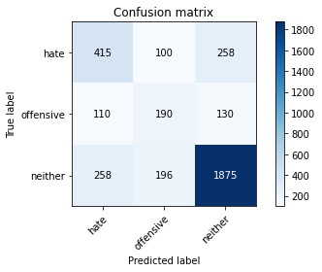

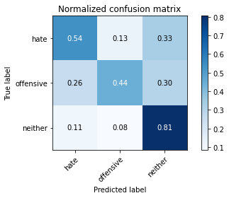

precision recall f1-score support

hate 0.53 0.54 0.53 773

offensive 0.39 0.44 0.41 430

neither 0.83 0.81 0.82 2329

accuracy 0.70 3532

macro avg 0.58 0.59 0.59 3532

weighted avg 0.71 0.70 0.71 3532

average eval_loss: 1.353055373676079, accuracy: 0.7021517553793885

training 8 epoch...

26.624391317367554 seconds used......

8 training finished! average train loss: 0.0232017021463595

evaluating...

Confusion matrix, without normalization

[[ 470 98 205]

[ 124 192 114]

[ 340 245 1744]]

Normalized confusion matrix

[[0.6080207 0.12677878 0.26520052]

[0.28837209 0.44651163 0.26511628]

[0.1459854 0.10519536 0.74881924]]

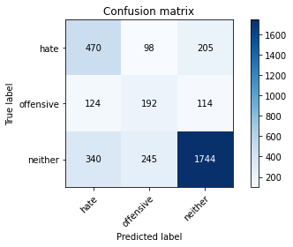

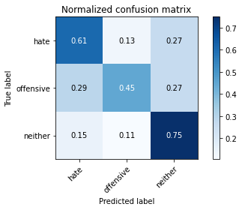

precision recall f1-score support

hate 0.50 0.61 0.55 773

offensive 0.36 0.45 0.40 430

neither 0.85 0.75 0.79 2329

accuracy 0.68 3532

macro avg 0.57 0.60 0.58 3532

weighted avg 0.71 0.68 0.69 3532

average eval_loss: 1.4963088773906568, accuracy: 0.6812004530011325

training 9 epoch...

26.600923538208008 seconds used......

9 training finished! average train loss: 0.009699901509413715

evaluating...

Confusion matrix, without normalization

[[ 449 70 254]

[ 127 163 140]

[ 280 143 1906]]

Normalized confusion matrix

[[0.58085382 0.09055627 0.32858991]

[0.29534884 0.37906977 0.3255814 ]

[0.12022327 0.06139974 0.81837699]]

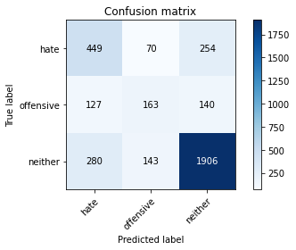

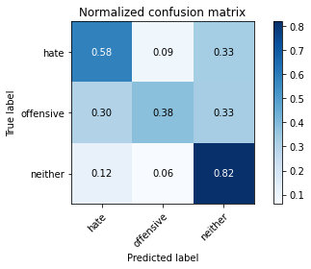

precision recall f1-score support

hate 0.52 0.58 0.55 773

offensive 0.43 0.38 0.40 430

neither 0.83 0.82 0.82 2329

accuracy 0.71 3532

macro avg 0.60 0.59 0.59 3532

weighted avg 0.71 0.71 0.71 3532

average eval_loss: 1.497785196465961, accuracy: 0.7129105322763307

training 10 epoch...

26.633678913116455 seconds used......

10 training finished! average train loss: 0.008743200269236695

evaluating...

Confusion matrix, without normalization

[[ 431 90 252]

[ 103 198 129]

[ 260 191 1878]]

Normalized confusion matrix

[[0.55756792 0.1164295 0.32600259]

[0.23953488 0.46046512 0.3 ]

[0.1116359 0.08200945 0.80635466]]

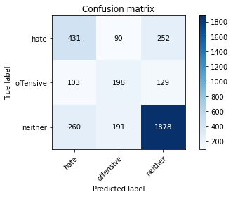

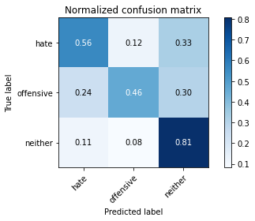

precision recall f1-score support

hate 0.54 0.56 0.55 773

offensive 0.41 0.46 0.44 430

neither 0.83 0.81 0.82 2329

accuracy 0.71 3532

macro avg 0.60 0.61 0.60 3532

weighted avg 0.72 0.71 0.71 3532

average eval_loss: 1.61923628742412, accuracy: 0.7097961494903737

3 run......

training 1 epoch...

26.611286878585815 seconds used......

1 training finished! average train loss: 0.8804378303534844

evaluating...

Confusion matrix, without normalization

[[ 489 0 284]

[ 198 0 232]

[ 429 0 1900]]

Normalized confusion matrix

[[0.63260026 0. 0.36739974]

[0.46046512 0. 0.53953488]

[0.18419923 0. 0.81580077]]

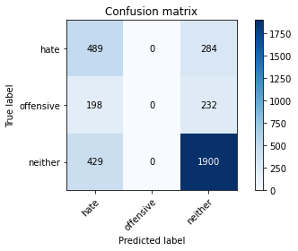

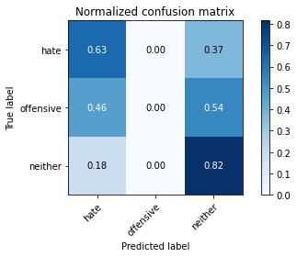

/opt/conda/lib/python3.7/site-packages/sklearn/metrics/_classification.py:1245: UndefinedMetricWarning: Precision and F-score are ill-defined and being set to 0.0 in labels with no predicted samples. Use `zero_division` parameter to control this behavior.

_warn_prf(average, modifier, msg_start, len(result))

/opt/conda/lib/python3.7/site-packages/sklearn/metrics/_classification.py:1245: UndefinedMetricWarning: Precision and F-score are ill-defined and being set to 0.0 in labels with no predicted samples. Use `zero_division` parameter to control this behavior.

_warn_prf(average, modifier, msg_start, len(result))

/opt/conda/lib/python3.7/site-packages/sklearn/metrics/_classification.py:1245: UndefinedMetricWarning: Precision and F-score are ill-defined and being set to 0.0 in labels with no predicted samples. Use `zero_division` parameter to control this behavior.

_warn_prf(average, modifier, msg_start, len(result))

precision recall f1-score support

hate 0.44 0.63 0.52 773

offensive 0.00 0.00 0.00 430

neither 0.79 0.82 0.80 2329

accuracy 0.68 3532

macro avg 0.41 0.48 0.44 3532

weighted avg 0.61 0.68 0.64 3532

average eval_loss: 0.6897808980133574, accuracy: 0.6763873159682899

training 2 epoch...

26.501967668533325 seconds used......

2 training finished! average train loss: 0.6221689294804545

evaluating...

Confusion matrix, without normalization

[[ 450 7 316]

[ 163 50 217]

[ 271 20 2038]]

Normalized confusion matrix

[[0.58214748 0.00905563 0.4087969 ]

[0.37906977 0.11627907 0.50465116]

[0.11635895 0.00858738 0.87505367]]

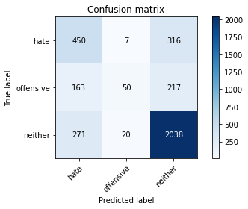

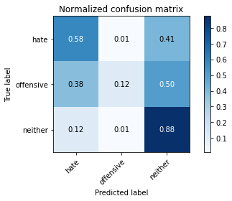

precision recall f1-score support

hate 0.51 0.58 0.54 773

offensive 0.65 0.12 0.20 430

neither 0.79 0.88 0.83 2329

accuracy 0.72 3532

macro avg 0.65 0.52 0.52 3532

weighted avg 0.71 0.72 0.69 3532

average eval_loss: 0.646169785894243, accuracy: 0.7185730464326161

training 3 epoch...

26.63416290283203 seconds used......

3 training finished! average train loss: 0.4161441022639765

evaluating...

Confusion matrix, without normalization

[[ 528 50 195]

[ 158 138 134]

[ 447 141 1741]]

Normalized confusion matrix

[[0.68305304 0.06468305 0.25226391]

[0.36744186 0.32093023 0.31162791]

[0.19192787 0.060541 0.74753113]]

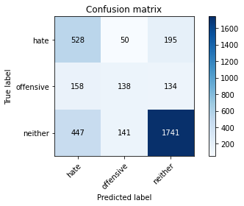

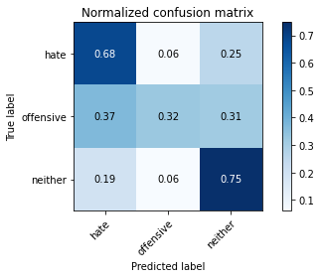

precision recall f1-score support

hate 0.47 0.68 0.55 773

offensive 0.42 0.32 0.36 430

neither 0.84 0.75 0.79 2329

accuracy 0.68 3532

macro avg 0.58 0.58 0.57 3532

weighted avg 0.71 0.68 0.69 3532

average eval_loss: 0.7576784887219553, accuracy: 0.6814835787089468

training 4 epoch...

26.657257556915283 seconds used......

4 training finished! average train loss: 0.21956317636239178

evaluating...

Confusion matrix, without normalization

[[ 434 65 274]

[ 122 134 174]

[ 285 115 1929]]

Normalized confusion matrix

[[0.5614489 0.08408797 0.35446313]

[0.28372093 0.31162791 0.40465116]

[0.12237012 0.04937742 0.82825247]]

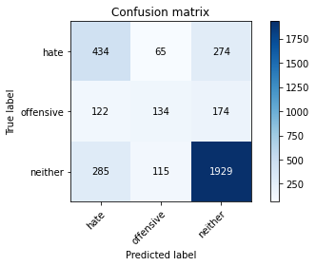

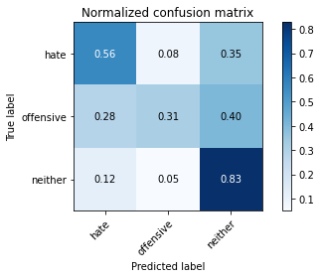

precision recall f1-score support

hate 0.52 0.56 0.54 773

offensive 0.43 0.31 0.36 430

neither 0.81 0.83 0.82 2329

accuracy 0.71 3532

macro avg 0.58 0.57 0.57 3532

weighted avg 0.70 0.71 0.70 3532

average eval_loss: 0.9241352958951966, accuracy: 0.706964892412231

training 5 epoch...

26.667291402816772 seconds used......

5 training finished! average train loss: 0.09549205558484092

evaluating...

Confusion matrix, without normalization

[[ 415 83 275]

[ 98 164 168]

[ 263 133 1933]]

Normalized confusion matrix

[[0.53686934 0.10737387 0.35575679]

[0.22790698 0.38139535 0.39069767]

[0.112924 0.05710605 0.82996994]]

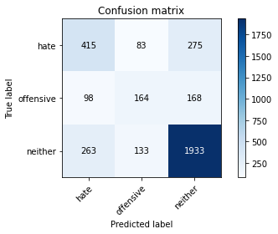

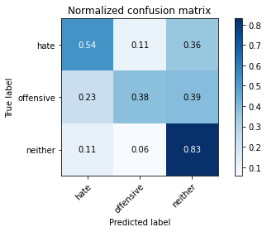

precision recall f1-score support

hate 0.53 0.54 0.54 773

offensive 0.43 0.38 0.40 430

neither 0.81 0.83 0.82 2329

accuracy 0.71 3532

macro avg 0.59 0.58 0.59 3532

weighted avg 0.71 0.71 0.71 3532

average eval_loss: 1.0815726884004087, accuracy: 0.711211778029445

training 6 epoch...

26.623451232910156 seconds used......

6 training finished! average train loss: 0.04429156138383619

evaluating...

Confusion matrix, without normalization

[[ 410 91 272]

[ 98 176 156]

[ 282 147 1900]]

Normalized confusion matrix

[[0.53040103 0.11772316 0.35187581]

[0.22790698 0.40930233 0.3627907 ]

[0.12108201 0.06311722 0.81580077]]

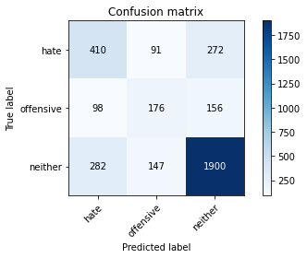

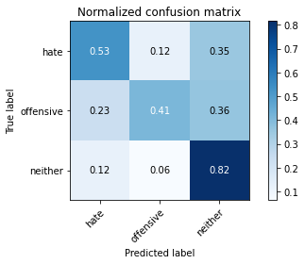

precision recall f1-score support

hate 0.52 0.53 0.52 773

offensive 0.43 0.41 0.42 430

neither 0.82 0.82 0.82 2329

accuracy 0.70 3532

macro avg 0.59 0.59 0.59 3532

weighted avg 0.70 0.70 0.70 3532

average eval_loss: 1.2754080263992487, accuracy: 0.703850509626274

training 7 epoch...

26.49825954437256 seconds used......

7 training finished! average train loss: 0.0336845369927366

evaluating...

Confusion matrix, without normalization

[[ 381 134 258]

[ 80 216 134]

[ 251 224 1854]]

Normalized confusion matrix

[[0.49288486 0.17335058 0.33376455]

[0.18604651 0.50232558 0.31162791]

[0.10777158 0.09617862 0.79604981]]

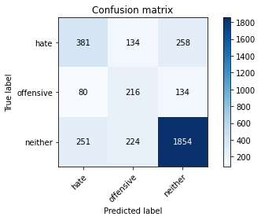

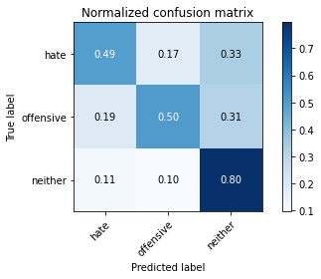

precision recall f1-score support

hate 0.54 0.49 0.51 773

offensive 0.38 0.50 0.43 430

neither 0.83 0.80 0.81 2329

accuracy 0.69 3532

macro avg 0.58 0.60 0.58 3532

weighted avg 0.71 0.69 0.70 3532

average eval_loss: 1.4125688856436034, accuracy: 0.6939411098527747

training 8 epoch...

26.59850263595581 seconds used......

8 training finished! average train loss: 0.01592228198184303

evaluating...

Confusion matrix, without normalization

[[ 391 161 221]

[ 74 237 119]

[ 252 315 1762]]

Normalized confusion matrix

[[0.50582147 0.20827943 0.28589909]

[0.17209302 0.55116279 0.27674419]

[0.10820094 0.13525118 0.75654787]]

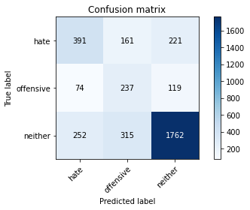

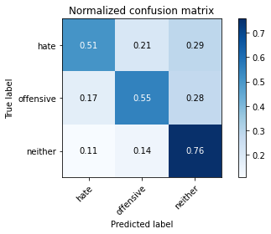

precision recall f1-score support

hate 0.55 0.51 0.52 773

offensive 0.33 0.55 0.41 430

neither 0.84 0.76 0.80 2329

accuracy 0.68 3532

macro avg 0.57 0.60 0.58 3532

weighted avg 0.71 0.68 0.69 3532

average eval_loss: 1.6164582769917903, accuracy: 0.6766704416761042

training 9 epoch...

26.562954902648926 seconds used......

9 training finished! average train loss: 0.009057096535637838

evaluating...

Confusion matrix, without normalization

[[ 400 151 222]

[ 79 235 116]

[ 281 295 1753]]

Normalized confusion matrix

[[0.51746442 0.19534282 0.28719276]

[0.18372093 0.54651163 0.26976744]

[0.12065264 0.1266638 0.75268356]]

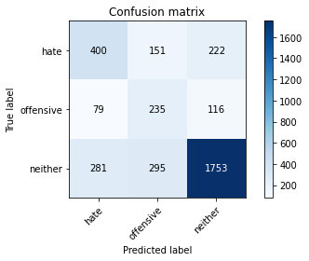

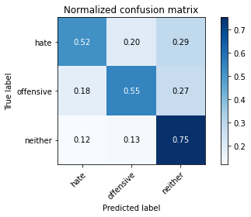

precision recall f1-score support

hate 0.53 0.52 0.52 773

offensive 0.35 0.55 0.42 430

neither 0.84 0.75 0.79 2329

accuracy 0.68 3532

macro avg 0.57 0.61 0.58 3532

weighted avg 0.71 0.68 0.69 3532

average eval_loss: 1.631372385526781, accuracy: 0.6761041902604756

training 10 epoch...

26.531592845916748 seconds used......

10 training finished! average train loss: 0.004354227969837238

evaluating...

Confusion matrix, without normalization

[[ 419 107 247]

[ 86 211 133]

[ 283 220 1826]]

Normalized confusion matrix

[[0.54204398 0.13842173 0.31953428]

[0.2 0.49069767 0.30930233]

[0.12151138 0.09446114 0.78402748]]

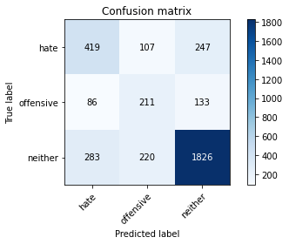

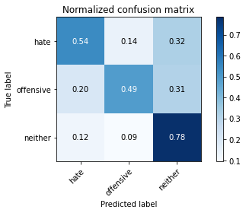

precision recall f1-score support

hate 0.53 0.54 0.54 773

offensive 0.39 0.49 0.44 430

neither 0.83 0.78 0.81 2329

accuracy 0.70 3532

macro avg 0.58 0.61 0.59 3532

weighted avg 0.71 0.70 0.70 3532

average eval_loss: 1.6212210927558484, accuracy: 0.695356738391846

4 run......

training 1 epoch...

26.46937847137451 seconds used......

1 training finished! average train loss: 0.8626368072103051

evaluating...

Confusion matrix, without normalization

[[ 506 0 267]

[ 246 0 184]

[ 484 0 1845]]

Normalized confusion matrix

[[0.6545925 0. 0.3454075 ]

[0.57209302 0. 0.42790698]

[0.20781451 0. 0.79218549]]

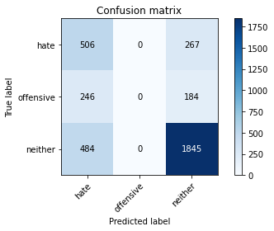

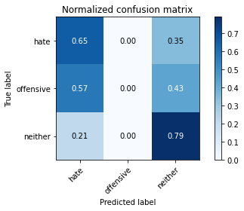

/opt/conda/lib/python3.7/site-packages/sklearn/metrics/_classification.py:1245: UndefinedMetricWarning: Precision and F-score are ill-defined and being set to 0.0 in labels with no predicted samples. Use `zero_division` parameter to control this behavior.

_warn_prf(average, modifier, msg_start, len(result))

/opt/conda/lib/python3.7/site-packages/sklearn/metrics/_classification.py:1245: UndefinedMetricWarning: Precision and F-score are ill-defined and being set to 0.0 in labels with no predicted samples. Use `zero_division` parameter to control this behavior.

_warn_prf(average, modifier, msg_start, len(result))

/opt/conda/lib/python3.7/site-packages/sklearn/metrics/_classification.py:1245: UndefinedMetricWarning: Precision and F-score are ill-defined and being set to 0.0 in labels with no predicted samples. Use `zero_division` parameter to control this behavior.

_warn_prf(average, modifier, msg_start, len(result))

precision recall f1-score support

hate 0.41 0.65 0.50 773

offensive 0.00 0.00 0.00 430

neither 0.80 0.79 0.80 2329

accuracy 0.67 3532

macro avg 0.40 0.48 0.43 3532

weighted avg 0.62 0.67 0.64 3532

average eval_loss: 0.6920300765899615, accuracy: 0.6656285390713477

training 2 epoch...

26.619364976882935 seconds used......

2 training finished! average train loss: 0.620558572056539

evaluating...

Confusion matrix, without normalization

[[ 634 13 126]

[ 267 78 85]

[ 781 86 1462]]

Normalized confusion matrix

[[0.82018111 0.01681759 0.16300129]

[0.62093023 0.18139535 0.19767442]

[0.33533705 0.03692572 0.62773723]]

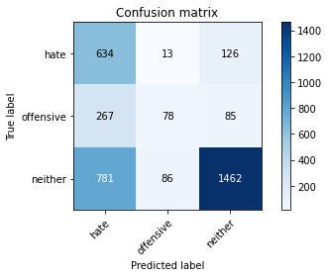

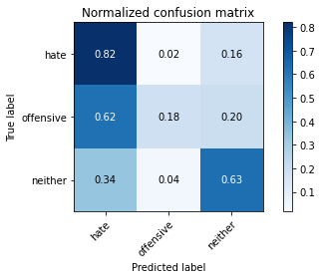

precision recall f1-score support

hate 0.38 0.82 0.52 773

offensive 0.44 0.18 0.26 430

neither 0.87 0.63 0.73 2329

accuracy 0.62 3532

macro avg 0.56 0.54 0.50 3532

weighted avg 0.71 0.62 0.63 3532

average eval_loss: 0.8251856536851765, accuracy: 0.6155152887882219

training 3 epoch...

26.51220440864563 seconds used......

3 training finished! average train loss: 0.42673928838442354

evaluating...

Confusion matrix, without normalization

[[ 537 49 187]

[ 196 119 115]

[ 490 156 1683]]

Normalized confusion matrix

[[0.69469599 0.06338939 0.24191462]

[0.45581395 0.27674419 0.26744186]

[0.21039073 0.06698154 0.72262774]]

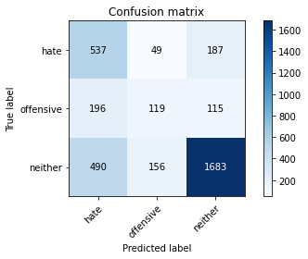

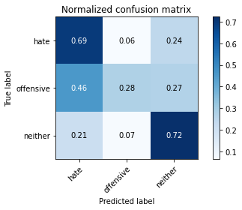

precision recall f1-score support

hate 0.44 0.69 0.54 773

offensive 0.37 0.28 0.32 430

neither 0.85 0.72 0.78 2329

accuracy 0.66 3532

macro avg 0.55 0.56 0.54 3532

weighted avg 0.70 0.66 0.67 3532

average eval_loss: 0.791802360513116, accuracy: 0.6622310305775765

training 4 epoch...

26.553882122039795 seconds used......

4 training finished! average train loss: 0.24521460729267666

evaluating...

Confusion matrix, without normalization

[[ 517 39 217]

[ 200 100 130]

[ 415 134 1780]]

Normalized confusion matrix

[[0.66882277 0.05045278 0.28072445]

[0.46511628 0.23255814 0.30232558]

[0.17818806 0.05753542 0.76427651]]

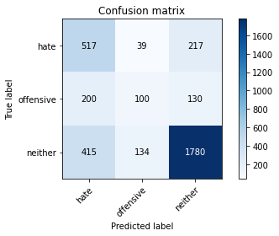

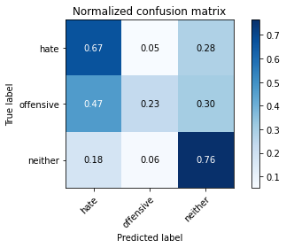

precision recall f1-score support

hate 0.46 0.67 0.54 773

offensive 0.37 0.23 0.28 430

neither 0.84 0.76 0.80 2329

accuracy 0.68 3532

macro avg 0.55 0.56 0.54 3532

weighted avg 0.70 0.68 0.68 3532

average eval_loss: 0.8872231548115358, accuracy: 0.678652321630804

training 5 epoch...

26.554056406021118 seconds used......

5 training finished! average train loss: 0.10955531999249668

evaluating...

Confusion matrix, without normalization

[[ 424 127 222]

[ 96 213 121]

[ 298 245 1786]]

Normalized confusion matrix

[[0.54851229 0.16429495 0.28719276]

[0.22325581 0.49534884 0.28139535]

[0.12795191 0.10519536 0.76685273]]

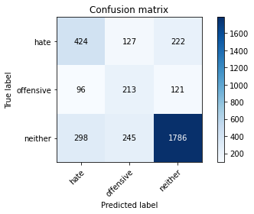

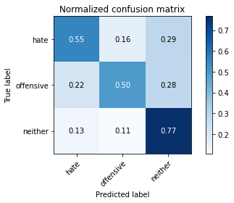

precision recall f1-score support

hate 0.52 0.55 0.53 773

offensive 0.36 0.50 0.42 430

neither 0.84 0.77 0.80 2329

accuracy 0.69 3532

macro avg 0.57 0.60 0.58 3532

weighted avg 0.71 0.69 0.70 3532

average eval_loss: 1.169206779218663, accuracy: 0.6860135900339751

training 6 epoch...

26.54687190055847 seconds used......

6 training finished! average train loss: 0.048108358288813824

evaluating...

Confusion matrix, without normalization

[[ 357 173 243]

[ 75 227 128]

[ 221 293 1815]]

Normalized confusion matrix

[[0.461837 0.22380336 0.31435964]

[0.1744186 0.52790698 0.29767442]

[0.09489051 0.12580507 0.77930442]]

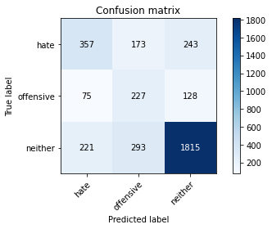

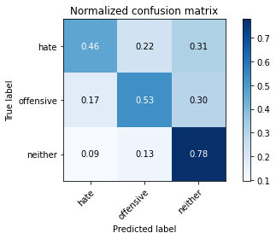

precision recall f1-score support

hate 0.55 0.46 0.50 773

offensive 0.33 0.53 0.40 430

neither 0.83 0.78 0.80 2329

accuracy 0.68 3532

macro avg 0.57 0.59 0.57 3532

weighted avg 0.71 0.68 0.69 3532

average eval_loss: 1.3786268464926272, accuracy: 0.6792185730464326

training 7 epoch...

26.507939100265503 seconds used......

7 training finished! average train loss: 0.028711993339718047

evaluating...

Confusion matrix, without normalization

[[ 472 89 212]

[ 112 192 126]

[ 351 216 1762]]

Normalized confusion matrix

[[0.61060802 0.11513583 0.27425614]

[0.26046512 0.44651163 0.29302326]

[0.15070846 0.09274367 0.75654787]]

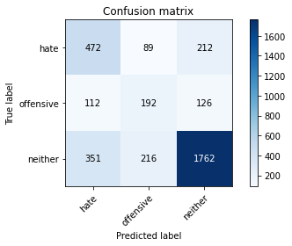

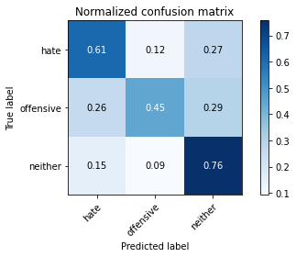

precision recall f1-score support

hate 0.50 0.61 0.55 773

offensive 0.39 0.45 0.41 430

neither 0.84 0.76 0.80 2329

accuracy 0.69 3532

macro avg 0.58 0.60 0.59 3532

weighted avg 0.71 0.69 0.70 3532

average eval_loss: 1.3928585544144367, accuracy: 0.6868629671574179

training 8 epoch...

26.565287351608276 seconds used......

8 training finished! average train loss: 0.0165700241272776

evaluating...

Confusion matrix, without normalization

[[ 532 46 195]

[ 177 142 111]

[ 447 160 1722]]

Normalized confusion matrix

[[0.68822768 0.05950841 0.25226391]

[0.41162791 0.33023256 0.25813953]

[0.19192787 0.06869901 0.73937312]]

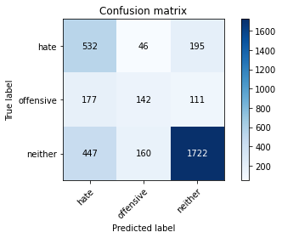

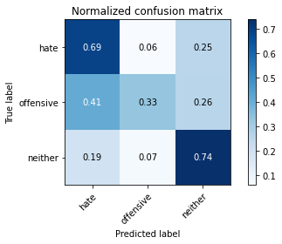

precision recall f1-score support

hate 0.46 0.69 0.55 773

offensive 0.41 0.33 0.37 430

neither 0.85 0.74 0.79 2329

accuracy 0.68 3532

macro avg 0.57 0.59 0.57 3532

weighted avg 0.71 0.68 0.69 3532

average eval_loss: 1.4349819206248569, accuracy: 0.6783691959229898

training 9 epoch...

26.54841136932373 seconds used......

9 training finished! average train loss: 0.016049072448153952

evaluating...

Confusion matrix, without normalization

[[ 421 106 246]

[ 87 204 139]

[ 282 231 1816]]

Normalized confusion matrix

[[0.54463131 0.13712807 0.31824062]

[0.20232558 0.4744186 0.32325581]

[0.12108201 0.0991842 0.77973379]]

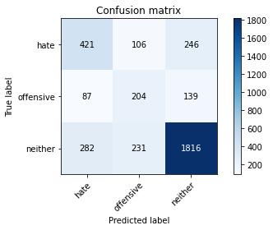

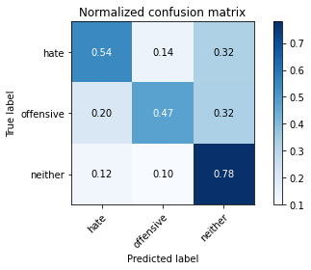

precision recall f1-score support

hate 0.53 0.54 0.54 773

offensive 0.38 0.47 0.42 430

neither 0.83 0.78 0.80 2329

accuracy 0.69 3532

macro avg 0.58 0.60 0.59 3532

weighted avg 0.71 0.69 0.70 3532

average eval_loss: 1.5148214984074824, accuracy: 0.6911098527746319

training 10 epoch...

26.55863094329834 seconds used......

10 training finished! average train loss: 0.006578519462731064

evaluating...

Confusion matrix, without normalization

[[ 394 131 248]

[ 77 218 135]

[ 269 237 1823]]

Normalized confusion matrix

[[0.50970246 0.1694696 0.32082794]

[0.17906977 0.50697674 0.31395349]

[0.11550021 0.10176041 0.78273937]]

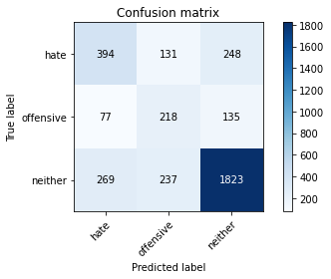

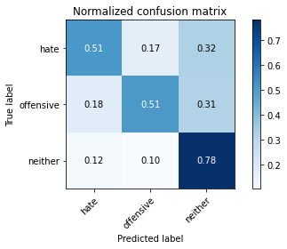

precision recall f1-score support

hate 0.53 0.51 0.52 773

offensive 0.37 0.51 0.43 430

neither 0.83 0.78 0.80 2329

accuracy 0.69 3532

macro avg 0.58 0.60 0.58 3532

weighted avg 0.71 0.69 0.70 3532

average eval_loss: 1.616189696441936, accuracy: 0.6894110985277463

5 run......

training 1 epoch...

26.508700132369995 seconds used......

1 training finished! average train loss: 0.8763655465753639

evaluating...

Confusion matrix, without normalization

[[ 635 1 137]

[ 299 14 117]

[ 815 30 1484]]

Normalized confusion matrix

[[0.82147477 0.00129366 0.17723157]

[0.69534884 0.03255814 0.27209302]

[0.34993559 0.01288106 0.63718334]]

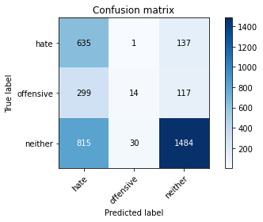

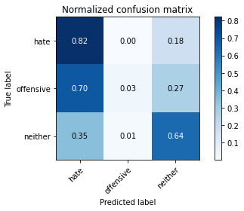

precision recall f1-score support

hate 0.36 0.82 0.50 773

offensive 0.31 0.03 0.06 430

neither 0.85 0.64 0.73 2329

accuracy 0.60 3532

macro avg 0.51 0.50 0.43 3532

weighted avg 0.68 0.60 0.60 3532

average eval_loss: 0.8116983927912631, accuracy: 0.603907134767837

training 2 epoch...

26.526313543319702 seconds used......

2 training finished! average train loss: 0.6328927751849679

evaluating...

Confusion matrix, without normalization

[[ 465 18 290]

[ 161 80 189]

[ 296 39 1994]]

Normalized confusion matrix

[[0.60155239 0.0232859 0.37516171]

[0.3744186 0.18604651 0.43953488]

[0.12709317 0.01674538 0.85616144]]

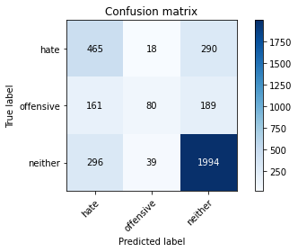

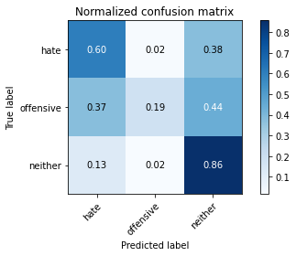

precision recall f1-score support

hate 0.50 0.60 0.55 773

offensive 0.58 0.19 0.28 430

neither 0.81 0.86 0.83 2329

accuracy 0.72 3532

macro avg 0.63 0.55 0.55 3532

weighted avg 0.71 0.72 0.70 3532

average eval_loss: 0.6367098409577278, accuracy: 0.7188561721404304

training 3 epoch...

26.546762943267822 seconds used......

3 training finished! average train loss: 0.4111732509644592

evaluating...

Confusion matrix, without normalization

[[ 508 26 239]

[ 175 89 166]

[ 372 52 1905]]

Normalized confusion matrix

[[0.65717982 0.03363519 0.30918499]

[0.40697674 0.20697674 0.38604651]

[0.1597252 0.02232718 0.81794762]]

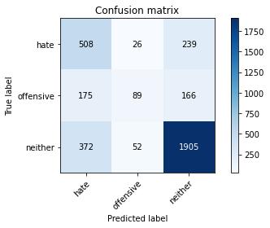

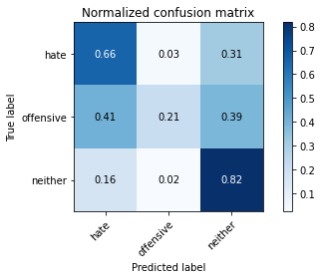

precision recall f1-score support

hate 0.48 0.66 0.56 773

offensive 0.53 0.21 0.30 430

neither 0.82 0.82 0.82 2329

accuracy 0.71 3532

macro avg 0.61 0.56 0.56 3532

weighted avg 0.71 0.71 0.70 3532

average eval_loss: 0.6950792878192696, accuracy: 0.7083805209513023

training 4 epoch...

26.525413751602173 seconds used......

4 training finished! average train loss: 0.21954730602309985

evaluating...

Confusion matrix, without normalization

[[ 449 120 204]

[ 111 208 111]

[ 336 248 1745]]

Normalized confusion matrix

[[0.58085382 0.15523933 0.26390686]

[0.25813953 0.48372093 0.25813953]

[0.14426793 0.10648347 0.7492486 ]]

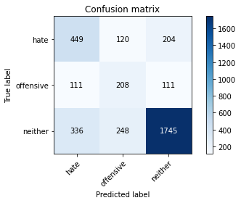

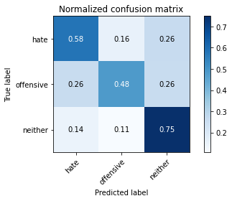

precision recall f1-score support

hate 0.50 0.58 0.54 773

offensive 0.36 0.48 0.41 430

neither 0.85 0.75 0.80 2329

accuracy 0.68 3532

macro avg 0.57 0.60 0.58 3532

weighted avg 0.71 0.68 0.69 3532

average eval_loss: 0.9562420754951272, accuracy: 0.6800679501698754

training 5 epoch...

26.573307752609253 seconds used......

5 training finished! average train loss: 0.10443135516663246

evaluating...

Confusion matrix, without normalization

[[ 342 99 332]

[ 84 175 171]

[ 157 145 2027]]

Normalized confusion matrix

[[0.44243208 0.12807245 0.42949547]

[0.19534884 0.40697674 0.39767442]

[0.06741091 0.06225848 0.87033061]]

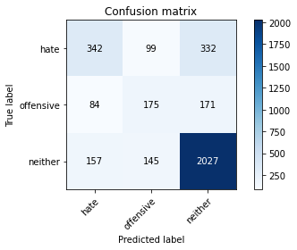

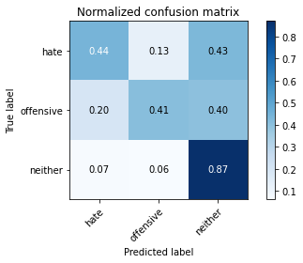

precision recall f1-score support

hate 0.59 0.44 0.50 773

offensive 0.42 0.41 0.41 430

neither 0.80 0.87 0.83 2329

accuracy 0.72 3532

macro avg 0.60 0.57 0.58 3532

weighted avg 0.71 0.72 0.71 3532

average eval_loss: 1.0999954979929885, accuracy: 0.7202718006795017

training 6 epoch...

26.486764907836914 seconds used......

6 training finished! average train loss: 0.054003564945613855

evaluating...

Confusion matrix, without normalization

[[ 423 121 229]

[ 118 197 115]

[ 303 206 1820]]

Normalized confusion matrix

[[0.54721863 0.15653299 0.29624838]

[0.2744186 0.45813953 0.26744186]

[0.13009875 0.08844998 0.78145127]]

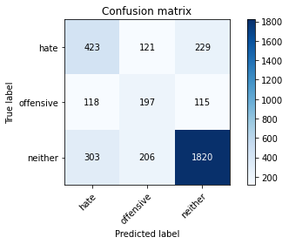

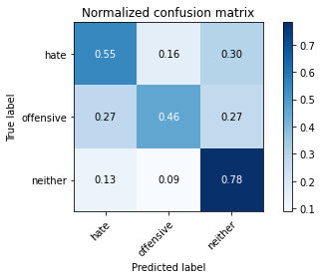

precision recall f1-score support

hate 0.50 0.55 0.52 773

offensive 0.38 0.46 0.41 430

neither 0.84 0.78 0.81 2329

accuracy 0.69 3532

macro avg 0.57 0.60 0.58 3532

weighted avg 0.71 0.69 0.70 3532

average eval_loss: 1.2378787383184595, accuracy: 0.6908267270668177

training 7 epoch...

26.514249563217163 seconds used......

7 training finished! average train loss: 0.024164963282494095

evaluating...

Confusion matrix, without normalization

[[ 419 91 263]

[ 97 167 166]

[ 262 137 1930]]

Normalized confusion matrix

[[0.54204398 0.11772316 0.34023286]

[0.2255814 0.38837209 0.38604651]

[0.11249463 0.05882353 0.82868184]]

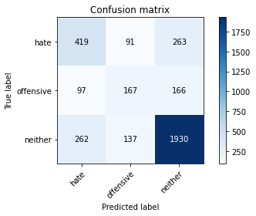

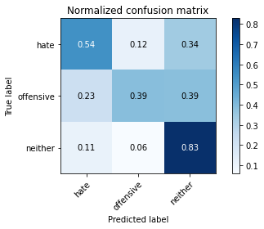

precision recall f1-score support

hate 0.54 0.54 0.54 773

offensive 0.42 0.39 0.40 430

neither 0.82 0.83 0.82 2329

accuracy 0.71 3532

macro avg 0.59 0.59 0.59 3532

weighted avg 0.71 0.71 0.71 3532

average eval_loss: 1.3091906038044536, accuracy: 0.7123442808607021

training 8 epoch...

26.547032594680786 seconds used......

8 training finished! average train loss: 0.014890383724431397

evaluating...

Confusion matrix, without normalization

[[ 415 75 283]

[ 103 173 154]

[ 248 151 1930]]

Normalized confusion matrix

[[0.53686934 0.09702458 0.36610608]

[0.23953488 0.40232558 0.35813953]

[0.10648347 0.06483469 0.82868184]]

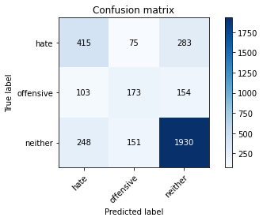

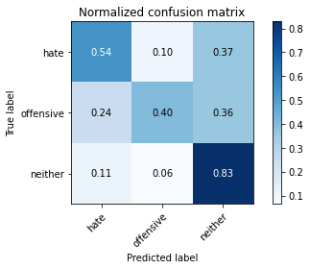

precision recall f1-score support

hate 0.54 0.54 0.54 773

offensive 0.43 0.40 0.42 430

neither 0.82 0.83 0.82 2329

accuracy 0.71 3532

macro avg 0.60 0.59 0.59 3532

weighted avg 0.71 0.71 0.71 3532

average eval_loss: 1.367996887046065, accuracy: 0.7129105322763307

training 9 epoch...

26.56851029396057 seconds used......

9 training finished! average train loss: 0.009454341438814642

evaluating...

Confusion matrix, without normalization

[[ 391 108 274]

[ 86 197 147]

[ 225 197 1907]]

Normalized confusion matrix

[[0.50582147 0.13971539 0.35446313]

[0.2 0.45813953 0.34186047]

[0.09660799 0.08458566 0.81880635]]

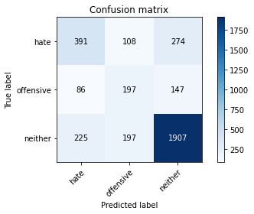

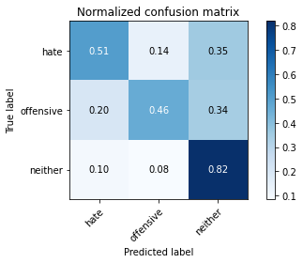

precision recall f1-score support

hate 0.56 0.51 0.53 773

offensive 0.39 0.46 0.42 430

neither 0.82 0.82 0.82 2329

accuracy 0.71 3532

macro avg 0.59 0.59 0.59 3532

weighted avg 0.71 0.71 0.71 3532

average eval_loss: 1.490633090926429, accuracy: 0.7063986409966025

training 10 epoch...

26.539948225021362 seconds used......

10 training finished! average train loss: 0.0102255249657901

evaluating...

Confusion matrix, without normalization

[[ 436 121 216]

[ 95 209 126]

[ 314 226 1789]]

Normalized confusion matrix

[[0.56403622 0.15653299 0.27943079]

[0.22093023 0.48604651 0.29302326]

[0.13482181 0.09703736 0.76814083]]

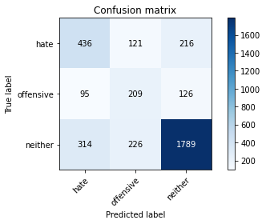

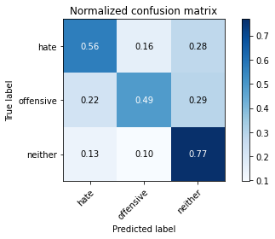

precision recall f1-score support

hate 0.52 0.56 0.54 773

offensive 0.38 0.49 0.42 430

neither 0.84 0.77 0.80 2329

accuracy 0.69 3532

macro avg 0.58 0.61 0.59 3532

weighted avg 0.71 0.69 0.70 3532

average eval_loss: 1.546336817455157, accuracy: 0.6891279728199321